SMART STUDY PLANNER
Programming Fundamentals Coursework Project
Faculty of Science and Technology
Module: 1203 ST – Programming Fundamentals | Level 1.2
Individual Assignment
Project title | The Smart Study Planner
Programming language | Python
Application type | Console-based program
Data storage | study_log.txt
GitHub repository | Github.com/femlagucci-star/SMART-STUDY PLANNER.

1. Introduction
The Smart Study Planner is a console-based Python program developed to help a student record, review and analyse study sessions for different subjects. The program stores the information in a text file so that previously entered sessions can be loaded again when the program is started.

2. Aim and Objectives
The main aim is to provide a simple study-session management tool. The program objectives are to:
- Provide a menu-driven interface for the user.
- Add study sessions containing subject, topic, date/day label and duration.
- Validate that session duration is a positive number.
- Classify sessions as Short, Medium or Long.
- Display all recorded sessions in a clear format.
- Search for sessions by subject without case sensitivity.
- Calculate overall and subject-based study statistics.
- Save records to study_log.txt and load them on the next run.

3. Program Structure
Function | Purpose
main() | Controls the menu, user choices and program flow.
add_session() | Collects session details and validates the duration.
classify_session(duration) | Returns Short, Medium or Long based on duration.
view_sessions() | Displays all sessions in a formatted table.
search_by_subject() | Finds sessions for a subject and calculates total time.
study_statistics() | Calculates overall hours, subject totals, weakest area and longest session.
save_sessions() | Stores sessions in study_log.txt.
load_sessions() | Loads saved sessions when the program starts.

4. Development and Implementation
The program was developed using separate functions rather than placing all instructions in one block. Study sessions are stored as dictionaries inside a list. Conditional statements are used to classify duration. The file-handling functions also account for the situation where study_log.txt does not yet exist.

5. Program Testing
The completed program was run from the Python interpreter. During the test, three sessions were entered, the sessions were displayed, a subject search was performed, statistics were calculated, and the program was saved and closed. The screenshots below are from that actual test execution.
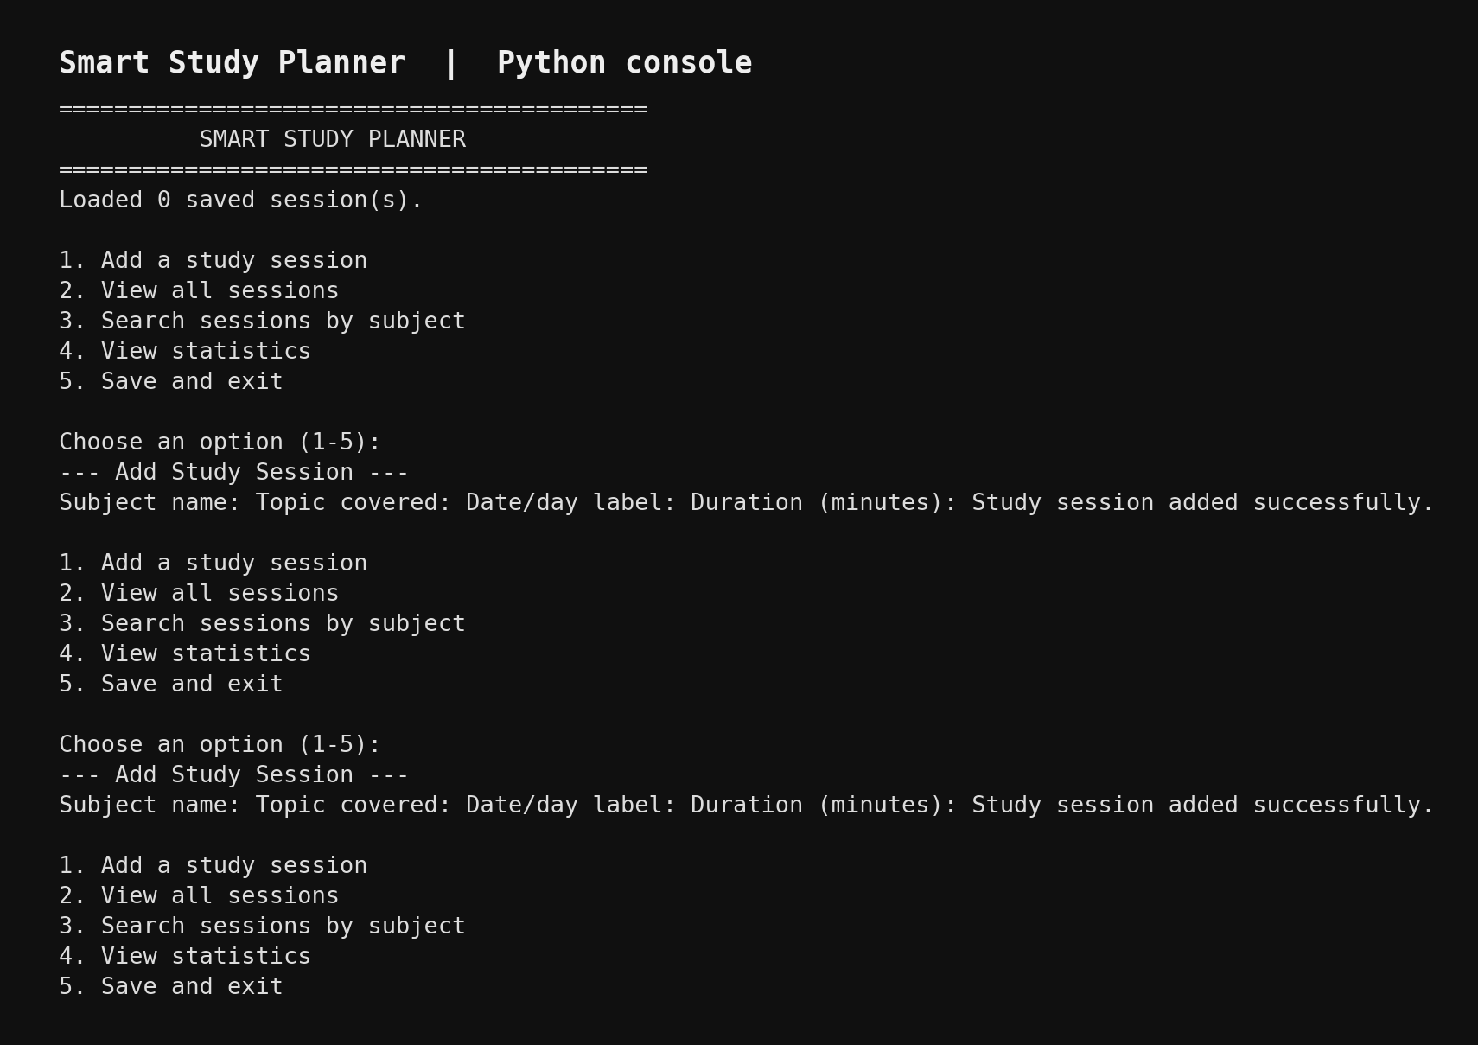
s.
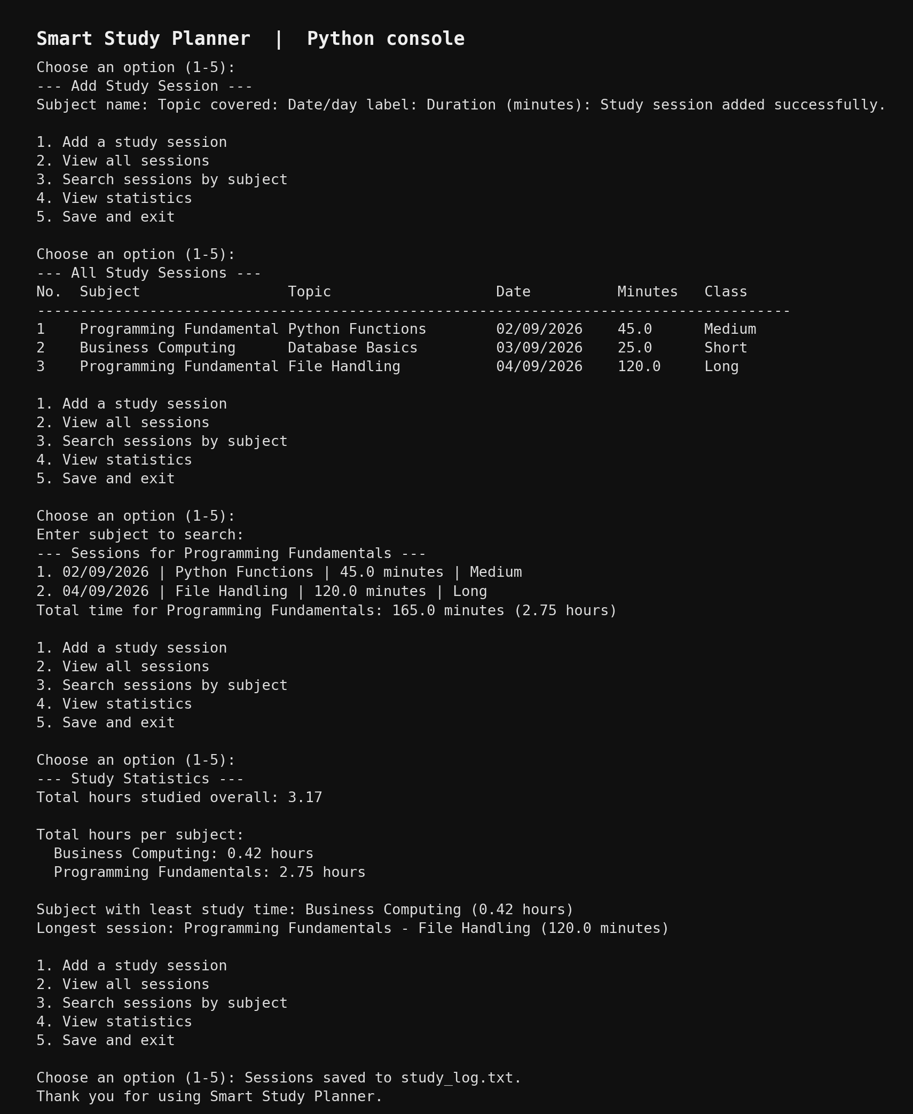

6. Test Cases and Results
Test case | Expected result | Result
Enter valid study session | Session is stored. | PASS
Enter invalid/non-positive duration | Program asks for a valid duration. | PASS
View all sessions | All sessions appear with classifications. | PASS
Search Programming Fundamentals | Matching sessions and total time are shown. | PASS
View statistics | Overall hours, subject totals, weakest subject and longest session appear. | PASS
Save and exit | Records are written to study_log.txt. | PASS
Load existing records | Saved sessions are available on startup. | PASS
Invalid menu choice | An error message appears without crashing. | PASS

7. Sample Test Data
The test run used Programming Fundamentals (45 minutes and 120 minutes) and Business Computing (25 minutes). Based on the classification rules, these sessions were classified as Medium, Long and Short respectively.

8. Conclusion
The Smart Study Planner successfully implements the required menu, study-session recording, classification, viewing, subject search, statistics and file-storage features. The program was executed successfully and the test results show that the main requirements operate as expected.

9.
GITHUB LINK
Github.com/femlagucci-star/SMART-STUDY PLANNER.

10. Source Code
The editable source code is included below so the complete coursework remains in one Word document.
FIL‘’from pathlib import path

E_NAME = "study_lo.txt"

def classify_session(duration):
if duration < 30:
return "Short"
elif duration <= 90:
return "Medium"
return "Long"

def search_by_subject(sessions):
subject = input("\nEnter subject to search: ").strip()
matches = [s for s in sessions if s["subject"].lower() == subject.lower()]

if not matches:
print(f"No sessions found for subject: {subject}")
return

total = 0
print(f"\n--- Sessions for {subject} ---")
for i, session in enumerate(matches, 1):
duration = session["duration"]

total += duration
pr("Topic covered: ").strip()
date_ def session(sessions):
= input("Date/day label: ").strip()

while True: print("\add n--- Add Study Session ---")
subject = input("Subject name: ").strip()
topic = input
try:
duration = float(input("Duration (minutes): "))
if duration > 0:
break
print("Please enter a positive number.")
except ValueError:
print("Invalid duration. Enter a number.")

sessions.append({
"subject": subject,
"topic": topic,
"date": date,
"duration": duration
})
print("Study session added successfully.")

def view_sessions(sessions):
print("\n--- All Study Sessions ---")
if not sessions:
print("No study sessions recorded yet.")
return

print(f"{'No.':<5}{'Subject':<24}{'Topic':<24}{'Date':<14}{'Minutes':<10}{'Class':<10}")
print("-" * 87)
for i, session in enumerate(sessions, 1):
duration = session["duration"]
print(
f"{i:<5}{session['subject'][:23]:<24}"
f"{session['topic'][:23]:<24}{session['date'][:13]:<14}"
f"{duration:<10.1f}{classify_session(duration):<10}"
)

int(f"{i}. {session['date']} | {session['topic']} | "
f"{duration:.1f} minutes | {classify_session(duration)}")
print(f"Total time for {subject}: {total:.1f} minutes ({total / 60:.2f} hours)")

def study_statistics(sessions):
print("\n--- Study Statistics ---")
if not sessions:
print("No data available. Add study sessions first.")
return

total_minutes = sum(s["duration"] for s in sessions)
print(f"Total hours studied overall: {total_minutes / 60:.2f}")

subject_totals = {}
for session in sessions:
subject = session["subject"]
subject_totals[subject] = subject_totals.get(subject, 0) + session["duration"]

print("\nTotal hours per subject:")
for subject, minutes in sorted(subject_totals.items()):
print(f" {subject}: {minutes / 60:.2f} hours")

weakest = min(subject_totals, key=subject_totals.get)
longest = max(sessions, key=lambda s: s["duration"])
print(f"\nSubject with least study time: {weakest} ({subject_totals[weakest] / 60:.2f} hours)")
print(f"Longest session: {longest['subject']} - {longest['topic']} "
f"({longest['duration']:.1f} minutes)")

def save_sessions(sessions):
with open(FILE_NAME, "w", encoding="utf-8") as file:
for s in sessions:
file.write(f"{s['subject']}|{s['topic']}|{s['date']}|{s['duration']}\n")

def load_sessions():
sessions = []
path = Path(FILE_NAME)

if not path.exists():
return sessions

try:
with path.open("r", encoding="utf-8") as file:
for line in file:
parts = line.rstrip("\n").split("|")
if len(parts) != 4:
continue
subject, topic, date, duration = parts
try:
sessions.append({
"subject": subject,
"topic": topic,
"date": date,
"duration": float(duration)
})
except ValueError:
continue
except OSError:
print("Warning: Could not read the study log.")
return sessions

def main():
sessions = load_sessions()
print("==========================================")
print(" SMART STUDY PLANNER")
print("==========================================")
print(f"Loaded {len(sessions)} saved session(s).")

while True:
print("\n1. Add a study session")
print("2. View all sessions")
print("3. Search sessions by subject")
print("4. View statistics")
print("5. Save and exit")

choice = input("\nChoose an option (1-5): ").strip()

if choice == "1":
add_session(sessions)
elif choice == "2":
view_sessions(sessions)
elif choice == "3":
search_by_subject(sessions)
elif choice == "4":
study_statistics(sessions)
elif choice == "5":
save_sessions(sessions)
print("Sessions saved to study_log.txt.")
print("Thank you for using Smart Study Planner.")
break
else:
print("Invalid choice. Please select a number from 1 to 5.")

if __name__ == "__main__":
main()

